Verizon Device Financing: Key Insights
A short read of what the 2023–24 application data show and what to do about it. Full analysis, tables and code are in Verizon_Risk_Model_Analysis.ipynb.

The short version
Verizon is turning away customers it would make money on. A funded plan earns +25% of the device price if repaid and loses 35% if it defaults, so a plan only loses money if the chance of default is above 41.7%. Even the riskiest group Verizon funds today defaults at about 17%, and the people it denies or loses to counteroffers would default at roughly 16–25%. Approving more of them, in steps, adds about $2.1M (+18%) to the $12.0M earned in the latest period.

Five insights

1. Verizon changed its own rules twice; customers didn't change
Approval rules loosened on 1 Aug 2023 (a promotion) and tightened on 1 May 2024. On both dates the risk score shifted for the same kind of applicant, and the approve/deny cut-offs moved. Credit scores, incomes, ages and devices requested stayed the same.
Period | Dates | Approved at first | Default rate (funded)
R1: baseline | Jan–Jul 2023 | 81.5% | 6.95%
R2: promotion | Aug 2023–Apr 2024 | 88.9% | 6.75%
R3: tightened | May–Dec 2024 | 71.4% | 10.69%

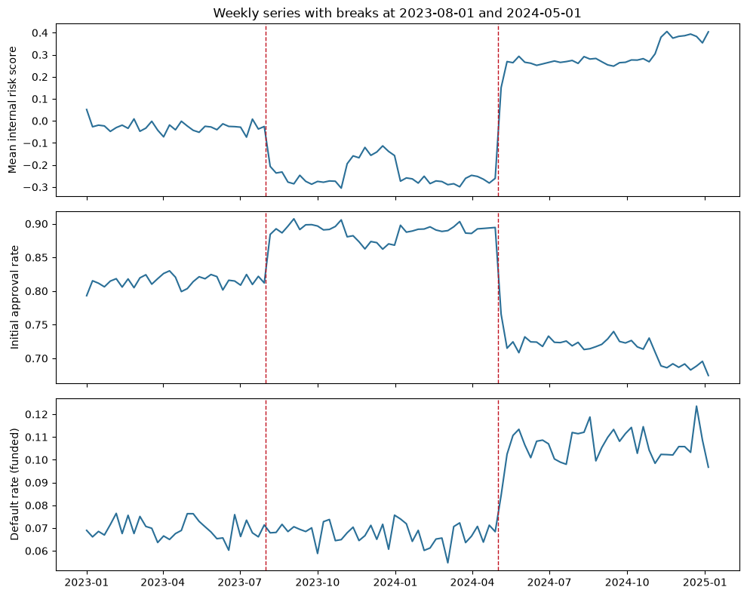
Weekly risk score, approval rate and default rate. The red lines mark the two rule changes.

2. Defaults rose because of an outside shock, not because of tighter rules
From May 2024, defaults rose 3–4 points in every risk band, for the same kind of applicant (about 55% higher). That points to an economic shock hitting everyone. Two claims don't hold up:
- “Tightening backfired.” It didn't. Had R3 kept R2's mix of approved customers, defaults would have been 11.2% instead of 10.7%, so tightening slightly helped. Its real cost was lost profit.
- “Defaults jump every May.” They don't. In 2023, May–December (6.9%) was no higher than January–April (7.0%). The 2024 jump is the regime change, and month adds nothing once it is accounted for (p = 0.77).
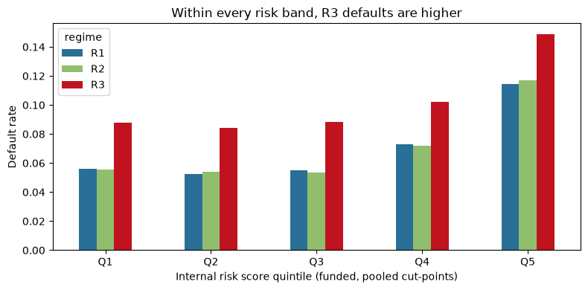
Default rate by risk-score quintile. R3 (red) is higher in every band, so the rise is not caused by who was approved.
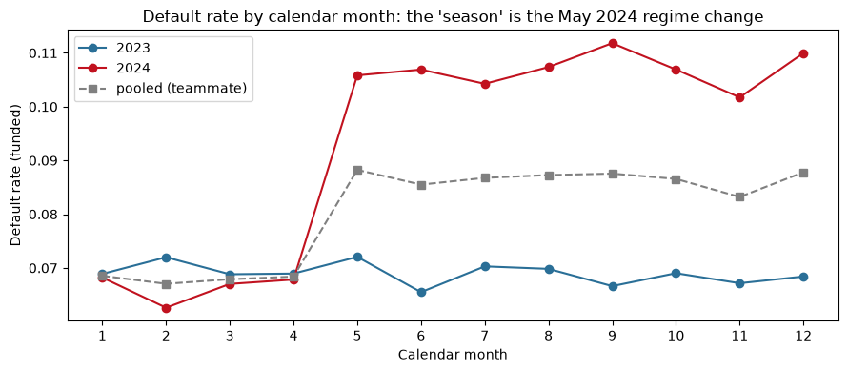
Default rate by calendar month. 2023 is flat all year; 2024 jumps on 1 May and stays there. Pooling the two years makes it look seasonal.

3. Counteroffers cost customers without reducing risk
Applicants in the middle band are offered a cheaper phone or a bigger down payment. Neither lowers default (no measurable effect, including right at the cut-off where applicants are otherwise alike). But 35–50% of those offered one walk away, and downgraded plans earn less. In R3, approving these applicants on the terms they asked for would have earned about $1.0M more.

4. The risk score works, but can be beaten simply
The internal risk score ranks default risk better than credit score alone (AUC 0.590 vs 0.563 on held-out data). A simple model using credit score, income, age, existing-customer status and the current period does better again (0.620) and gets the default level right in each period. Three patterns worth knowing:
- Age risk moves in steps, not smoothly: 11.9% default under 25, 7.5% from 25 to 66, 9.4% from 67. Ages are also heaped at round numbers (18, 21, 25, 30, 40, 65), right where the steps are.
- Existing customers get a score bonus but default more (9.1% vs 7.2%).
- Approvals swing with income far more than risk does: approval goes 40% → 97% → 38% from the lowest to the highest incomes, while default only moves 10.1% → 6.8% → 11.4%.
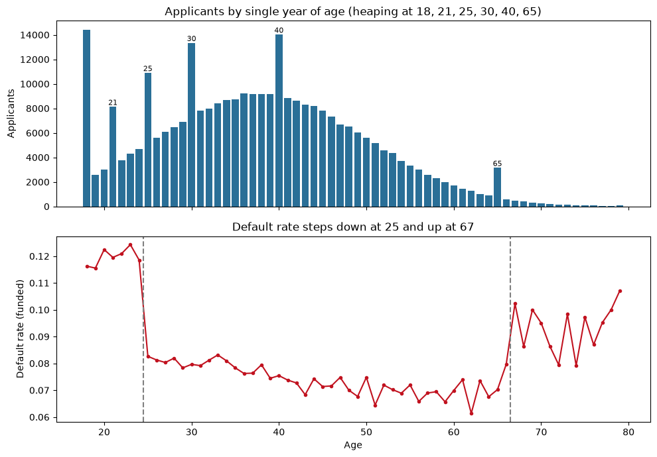
Top: applicants by age, with spikes at round ages. Bottom: default rate by age, with steps at 25 and 67.
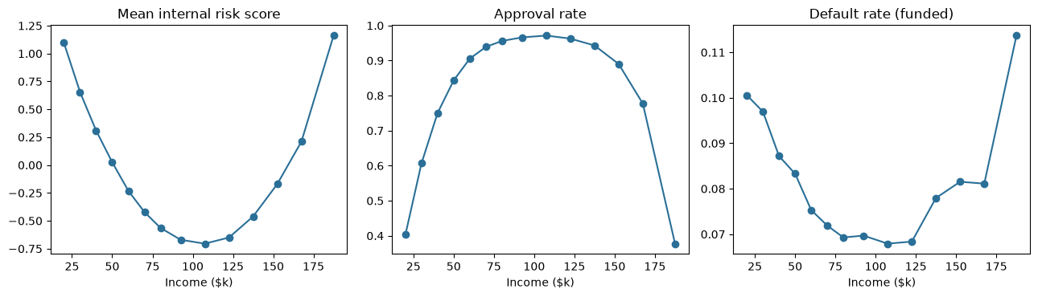
By income band: the risk score and approval rate swing sharply, while the default rate moves much less.

5. There is real evidence about many of today's denied applicants
62% of R3's not-funded applicants score above anyone Verizon funded, so a model built on funded plans can only guess about them. But the looser 2023–24 rules funded people with the same profile. After adjusting for the score shift, 87% of R3 denials (9,699) fall inside that range, and their expected default today is about 18%.
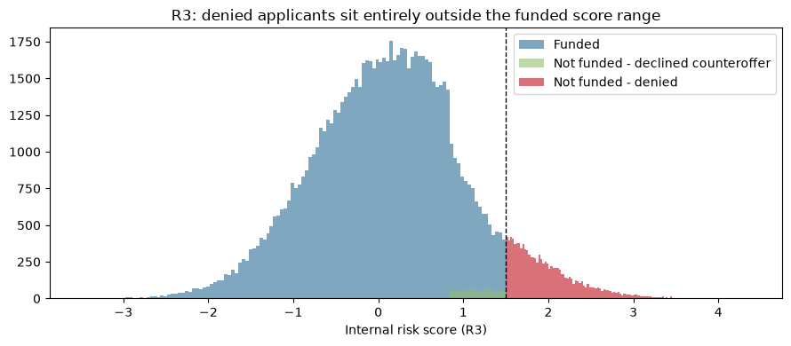
R3 risk-score distribution. Every denied applicant (red) scores above the highest funded score (dashed line).
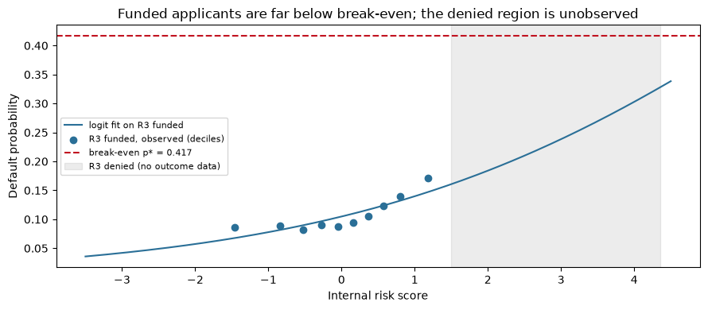
Default risk by score in R3. Funded customers sit well below the 41.7% break-even line; the grey area (denied applicants) has no outcome data.

What to do
Step | Confidence | Extra profit (per R3 period)
1. Approve conditional applicants on their requested terms | High | ≈ +$1.0M
2. Move the deny cut-off back to the 2023–24 level (1.50 → about 2.45 on today's scale) | Moderate | +$1.1M (still +$0.25M if defaults are double the estimate)
3. For the remaining ~1,500 highest-score denials, approve a random 10% as a test before changing policy | Unknown, so test | Information

- Replace or recalibrate the risk score with the simpler model, and verify date of birth near ages 25 and 67.
- Don't tighten seasonally, and judge any future tightening by profit, not the default rate.
- Guardrails: re-check default rates every quarter, stop automatically if new approvals default above about 30%, and check the new rules for fairness across race, ethnicity and gender before rollout.
Main caveat: the +25% / −35% profit rule is Verizon's own estimate and leaves out funding and collection costs. Even with a 50% loss on default, break-even is 33%, still well above every group observed.

